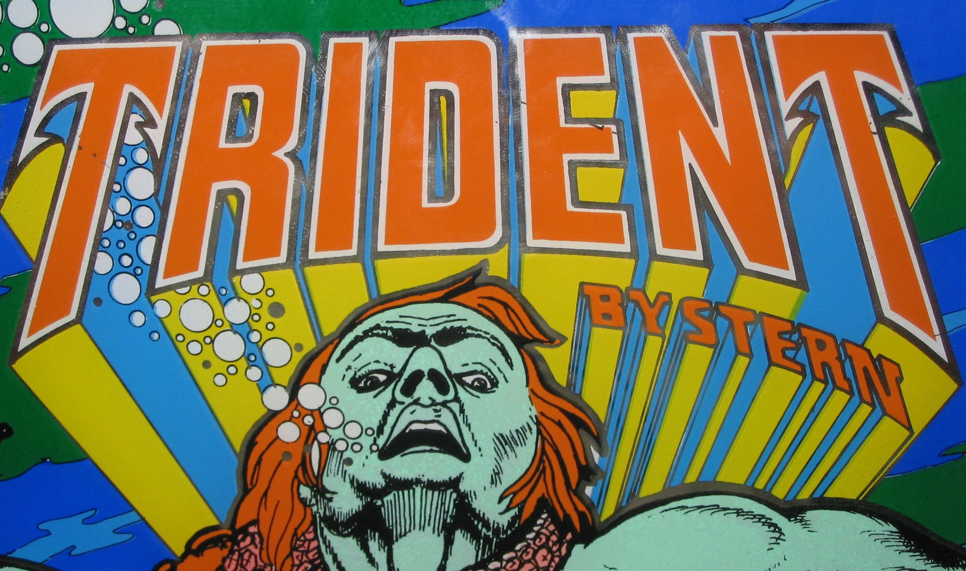

Model No.: 110
Released: March, 1979
Games Produced: 4,019 units
Design: Mike Kubin
Stern Electronics, Inc. (1977-1984)

Model No.: 110
Released: March, 1979
Games Produced: 4,019 units
Design: Mike Kubin
Stern Electronics, Inc. (1977-1984)

Model No.: 110
Released: March, 1979
Games Produced: 4,019 units
Design: Mike Kubin
Stern Electronics, Inc. (1977-1984)

