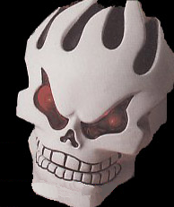
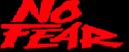

SKILL SHOT: Shoot Jump Ramp to collect selected award.
CHALLENGES: Shoot Start Challenge to start Challenge Modes. Listen to the Skull
for instructions. Complete all challenges to Meet Your Maker.
MULTI-BALL: Shoot Drop Target to light Locks. Shoot Skydive and Skull Jackpots
to light Super Jackpots.
SUPERCROSS Shoot alternating ramps to start Payback Time. Shoot all shots to
RAMPS: collect Big Points.
EXTRA BALL: Shoot consecutive raceways to light Extra Ball. Shoot skull to collect
Extra Ball.
KICKBACK: Shoot Cliff Targets to light Kickback.
TUBE SHOT: Awards random Features. Holds ball during Multi-Ball.
THE SUMMIT: Each Summit shot awards consecutive feature.
JUMP THIS: Shoot the Jump Ramp as many times for Maximum points.

