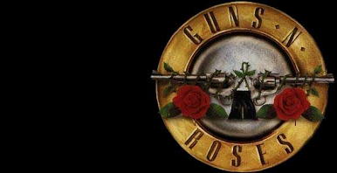
FREE PLAY
DESIGN: Joe Kaminkow, John Borg, Lyman F. Sheats Jr., Slash
ART: Markus Rothkranz

DOTS/ANIMATION: Kurt Anderson, Jack Liddon, Scott Melchionda
MUSIC: Axl Rose, Slash, Gilby Clarke, Brian Schmidt
SOUND: Brian Schmidt
SOFTWARE: Lonnie D. Ropp, Orin Day, Lyman F. Sheats Jr.

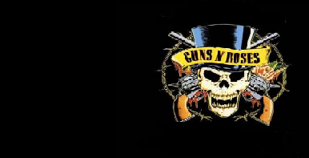
DESIGN: Joe Kaminkow, John Borg, Lyman F. Sheats Jr., Slash
ART: Markus Rothkranz

DOTS/ANIMATION: Kurt Anderson, Jack Liddon, Scott Melchionda
MUSIC: Axl Rose, Slash, Gilby Clarke, Brian Schmidt
SOUND: Brian Schmidt
SOFTWARE: Lonnie D. Ropp, Orin Day, Lyman F. Sheats Jr.
FREE PLAY

