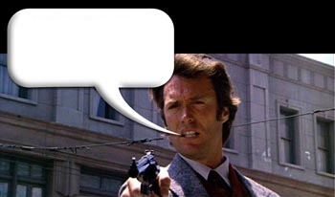
I know what you're thinking, punk: you're thinking, “Should I press the start button?” Well, you gotta ask yourself a question: 'Do I feel lucky?' Well, do ya, punk?
FREE PLAY

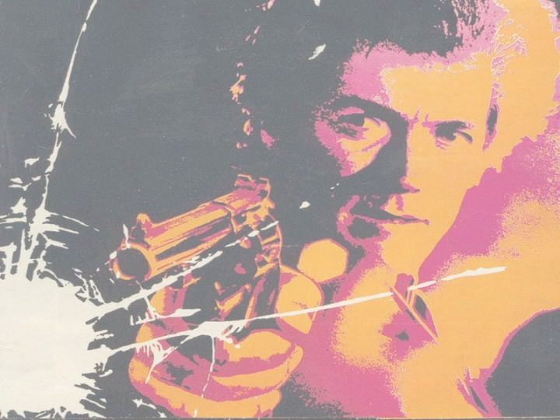
SKILL SHOT: WATCH DISPLAY & SELECT AWARD BY PULLING TRIGGER-‘RAMP SHOT’-‘LOAD
GUN’-‘RANDOM AWARD’.

MULTIBALL: COLLECT 5 BADGES TO LIGHT MULTIBALL. SHOOT LEFT RAMP OR
WAREHOUSE TO START. SHOOT RAMPS FOR ‘JACKPOTS’.

HQ MODES: OUTER LOOPS LIGHT ‘HQ’. SHOOTING ‘HQ’ WHEN LIT AWARDS CURRENT
FLASHING SHOTGUN SHELL MODE.

BULLET TARGETS: COMPLETE ALL 8 ‘BULLET’ TARGETS TO ADVANCE ‘MAGAZINE’ AWARDS. SHOOT WAREHOUSE TO COLLECT LOWEST FLASHING MAGAZINE AWARD.

TOP LANES & ‘RANSOM’: TOP LANES INCREASE JET BUMPER VALUE. JETS BUILD UP
‘RANSOM’. RIGHT RETURN LANE LIGHTS ‘HQ’ HOLE TO COLLECT ‘RANSOM’.

LEFT & RIGHT RAMPS: LEFT RAMP AWARDS PROMOTIONS IN ‘RANK’. ADVANCING RANK
LIGHTS SAFEHOUSE AWARD. RIGHT RAMP LIGHTS ‘FEEL LUCKY’. CONSECUTIVE RIGHT
RAMPS LIGHTS RICOCHET.

FEEL LUCKY: WATCH DISPLAY & SELECT INSTANT POINTS WITH LEFT FLIPPER. OR, USE
RIGHT FLIPPER TO SELECT OPPORTUNITY TO EARN YOUR FEATURE BY SHOOTING AT A
FLASHING TARGET WITH YOUR GUN.

