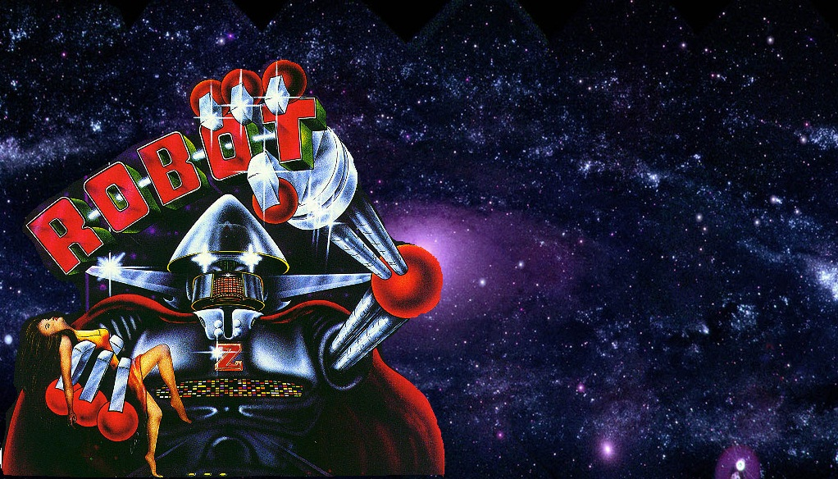

ROBOT
By ZACCARIA

Build date: January 1985
Zaccaria Generation 2 MPU
Art: Lorenzo Rimondini

3 BALLS PER GAME

Orange Special: Extra Ball
Red Special : REPLAY

2,000,000 PTS: 1 REPLAY
4,000,000 PTS: 1 REPLAY

ROBOT
By ZACCARIA

Build date: January 1985
Zaccaria Generation 2 MPU
Art: Lorenzo Rimondini

5 BALLS PER GAME

Orange Special: Extra Ball
Red Special : REPLAY

3,000,000 PTS: 1 REPLAY
5,000,000 PTS: 1 REPLAY



ROBOT

ROBOT BRIDGE
The 5 Robots in the middle of the playfield rise, when the ball is shot onto the “ROBOT BRIDGE”.
ROBOT TARGETS
Hit the “ROBOT” targets and advance their lights. When the word R-O-B-O-T is completed, the “RED SPECIAL” lights. Special is achieved by once again hitting the “ROBOT” targets.
DROPPING TARGETS
Hitting all the drop targets lights “TIME SPECIAL” and the “ORANGE SPECIAL” lights advance.
ORANGE SPECIAL
The orange special is scored by hitting the lit target.
BONUS MULTIPLIER
The BONUS MULTIPLIER is advanced by hitting the three “Z” fixed targets or by passing through the left-hand upper canal.
UPPER CANALS
Lights the “BALL RETURN” light.
BALL RETURN
When the ball return light is lit, that ball is returned to the player and counted as an extra ball.

