PIN•BOT™
• 3-Bank Drop Target advances Planets. Reach flashing Planet
for SPECIAL. Reach the SUN to light SPECIAL.
• Hitting flashing Light Bar, or Completing all lights on Chest
Panel opens VISOR for Multi-Ball™. Lighting Chest Panel 2nd
time lights EXTRA BALL.
• Ramp shot advances BONUS X and increases SOLAR Value.
• During Multi-Ball™, locking one ball and then shooting up Ramp
scores SOLAR Value.
• Jet Bumpers increase ENERGY Value.
• Each plunger shot advances VORTEX Value.

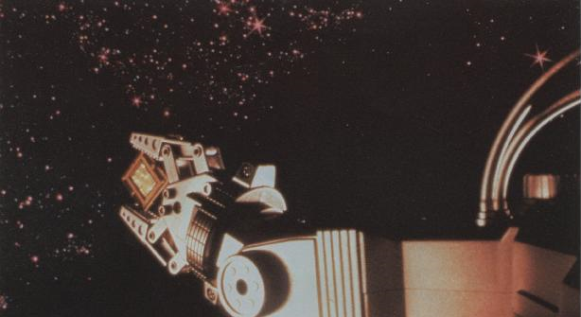
1 PLAY = $0.50
5 PLAYS = $2.00

