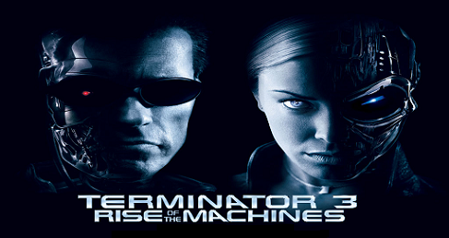
DESIGN: STEVE RITCHIE
ART: KEVIN O’CONNOR
MECHANICS: RAY TANZER
JOHN ROTHARMEL
STEVE RITCHIE
SOFTWARE: DWIGHT SULLIVAN
MUSIC: CHRIS GRANNER
STEVE RITCHIE
SOUND: CHRIS GRANNER
Year: 2003

DOTS/ANIMATION: MARK GALVEZ

