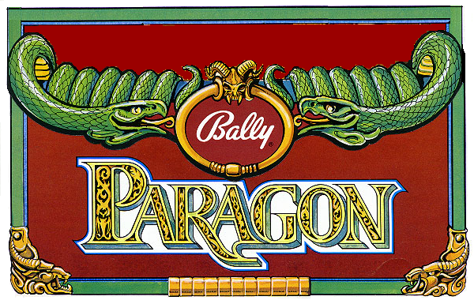
DESIGN: GREG KMIEC PRODUCTION: 9,120
YEAR: 1979

