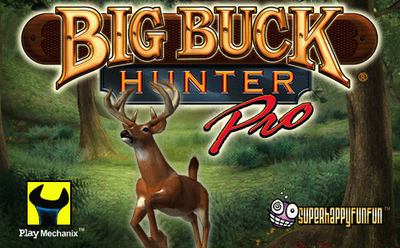

Free play

3 Balls per Play

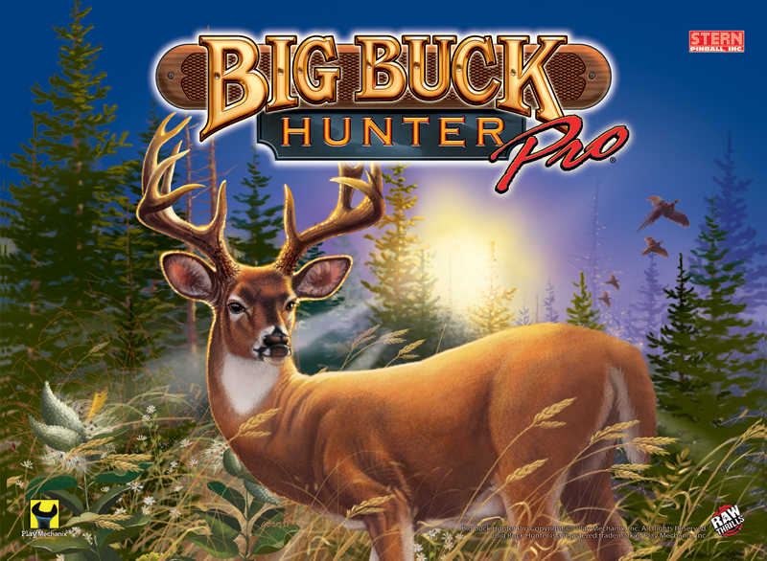

Moose on the Loose – Shoot the Left Ramp to spell M-O-O-S-E and start MOOSE ON THE LOOSE scoring round.
Pappy’s Porch – Complete the Left Strand-Up Targets for a MYSTERY AWARD.
Ram Double Scoring – Shoot the R-A-M to start DOUBLE SCORING.
Bonus Round – Shoot the Pop Bumpers to light Bonus Round at the Right Orbit. Shoot the Right Orbit to start a BONUS ROUND.
Big Buck Multiball – Shoot the Buck to light a Shotgun Shell. Collect all 5 Shotgun Shells to start BIG BUCK MULTIBALL.
Elk Multiball – Complete the Bottom Lanes to spell E-L-K and light Elk Hurry-Up at the Left Orbit. Shoot the Left Orbit to collect Elk Hurry-Up award and start ELK MULTIBALL.
Bird Multiball – Shoot the Bird Target to advance towards 1 or 4 Multiballs (PHEASANT, DOVE, DUCK, TURKEY).
Open Season – Collect Buck, Elk, Moose, Ram, Bird and Bonus Round awards to quality OPEN SEASON at the Bird Target.

